Web Human Resources (WebHR)
Version 1.0
C3-C1 Conversion Project

Installation Guide



September 2011

(WEBH*)

Department of Veterans Affairs
Office of Information and Technology (OIT)
Product Development (PD)

Revision History
Date | Revision | Description | Author
February 2011 | 1.0 | Initial version (template) | C Beynon
March 2011 | 1.0 | Copied WebHR install guide into template | C Beynon
June 2011 | 1.1 | Added updates from CJ and RA | C Beynon
July 2011 | 1.2 | Prepped for ESE Checklist | C Beynon
August 2011 | 1.3 | Changed dates to August 2011 | C Beynon
September 2011 | 1.4 | - Changed dates to September 2011  - Prepped for IOC Testing  - Added namespace: WEBH* | C Beynon
October 2011 | 1.5 | - Changed dates to October 2011  - Prepped for national release | C Beynon

Table of Contents
Introduction 1
Pre-installation Considerations 3
Installation Procedures 4
Install the Active Directory Lightweight Directory Services Role 4
Create the AD/LDS Instance 5
Replace the AD/LDS Instance with Centurion Files 12
Change the Server Name 13
Install the Application Server Role 14
Install Microsoft .NET 4.0- Framework 17
Install the Infragistics Net Advantage Web Client 2010 18
Install SQL Server 2008 26
Create SQL Login 44
Restore Database Backup Files 44
Turn on Database Chaining 48
Deploy WebHR Reports to the Report Server 48
Deploy the WebHR Code 50
Disable IIS Anonymous Authentication 50
Change Authentication Methods 50
Modify Default Application Pool 51
Add Applications to Pool 51
Change uploadReadAheadSize 59
Change Machine Configuration 59
Test Installation 59
Post-installation Considerations 60
Updating WebHR 60
Back-out/Uninstall Procedures 61
Troubleshooting Common Installation Issues 62

Introduction
Web Human Resources (WebHR) is a Class 3 (C3) automated human resources system that creates an electronic request for personnel actions, Standard Form 52 (SF-52) and tracks the document through the process. WebHR contains the elements necessary to process an SF-52 within a personnel office. This includes initiating, tracking, showing results, and finalizing a personnel action.

WebHR is a web-based, integrated module that brings workforce components together for Human Resources (HR) staff and managers to conduct online HR business activities. The application is designed with two interfaces: Customer Edition and Automated Human Resources Edition. The application also contains several reports, which assist both managers and HR staff with managing employees and recruitment activities.

There are two WebHR links on the WebHR SharePoint: http://vaww.htm.wmc.va.gov/HRIS/default.aspx
- WebHR Customer Edition for customers (service lines) to electronically submit an SF-52 to Human Resources.
- WebHR Automated Human Resources (HR) Edition for the HR staff to process an electronically submitted SF-52; and includes a Staffing Module that enables HR staff to enter and track hiring milestones and metrics.

WebHR receives data from the national Personnel and Accounting Integrated Data (PAID)/Veterans Health Information System Technology Architecture (VistA) system. WebHR is linked to the PAID database, which is a data warehouse for all VA personnel employee information. PAID is updated at the close of each pay period. The update allows employee-data to auto-populate an SF-52 when a form is initiated. The WebHR application, in its association with PAID data, allows for review of employee information.

Because WebHR operates in an integrated, secure, web-based environment, access and processes follow conventions dictated by an integrated, secure, web-based environment. Users interact with WebHR through Internet Explorer (IE) toolbars and menus.
Note: The WebHR application contains sensitive information and you must employ safeguards to ensure the security of the data contained within. Access to WebHR is granted through a formal request process.
WebHR is in production at all Veterans Health Administration (VHA) sites and at several VHA Program Offices. The Healthcare Talent Management (HTM) Office handles WebHR enhancements, training, and support.
Note: Contact your local WebHR Administrator with issues/concerns for the Web HR application.
Documentation
WebHR is compatible with Microsoft (MS) Office products and uses features like copy, paste, etc.
The Microsoft Office link: http://office.microsoft.com/en-us/help/default.aspx provides training, demos, and guides, as well as provides assistance with the variety of Microsoft versions used at individual sites.

There are three user manuals associated with the two editions of WebHR. The WebHR user manuals are available in MS Word (.docx) format and the Portable Document Format (.pdf) on the VA Software Documentation Library
http://www4.va.gov/vdl/

- WebHR Human Resources specialists use the WebHR User Manual for the Automated Human Resources Edition
- Local WebHR administrators use the WebHR User Manual for the Administrator Role
- WebHR customers (approvers/requesters/delegates) use the WebHR User Manual for the Customer Edition

Pre-installation Considerations
The installation prerequisites for the WebHR server, workstation software dependencies, and the operating system are:
- Windows Server 2008R2 installed and joined to a VA domain
- Infragistics Net Advantage 2010 Web Client license
- SQL Server 2008 Enterprise license
- The WebHR installation files with the following directory structure
- ADAM
- Applications
- Infragistics
- MicrosoftDOTNet4
- Services
- SQLDatabases
- SQLReports
- SQLServer2008
Note: This guide uses %WEBHR_FILES% when referencing the location of the WebHR installation files.

Installation Procedures

Install the Active Directory Lightweight Directory Services Role
To install the Active Directory Lightweight Directory Services (AD/LDS) Role:
- In Server Manager, click Add Roles.
- Select Active Directory Lightweight Directory Services.
- Click Next.
- Click Install.
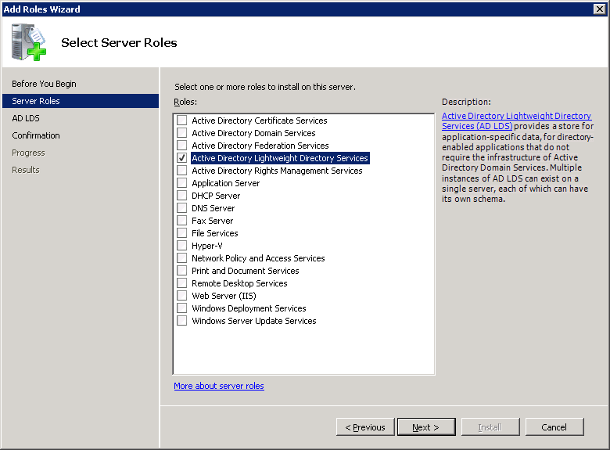
Add Roles Wizard window
Select Server Roles

Create the AD/LDS Instance
- To create the AD/LDS instance:
- Click Start Menu.
- Select to Administrative Tools.
- On Administrative Tools:
- Select the Active Directory Lightweight Directory Services Setup Wizard.
- Click Next.
- On Setup Options:
- Select the type of instance: A unique instance.
- Click Next.
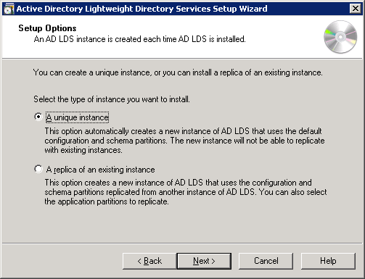
Active Directory Lightweight Directory Services Setup Wizard window
Select Options
- On Instance Name:
- In the Instance name box, type Centurion.
- In the Description box, type WebHR Centurion Instance.
- Click Next.
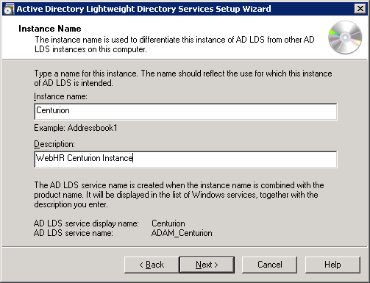
Active Directory Lightweight Directory Services Setup Wizard window
Instance Name
- On Ports:
- In the LDAP port number box, type 389.
- In the SSL port number box, type 636.
- Click Next.
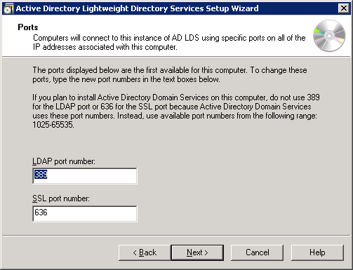
Active Directory Lightweight Directory Services Setup Wizard window
Ports
- On Application Directory Partition:
- Select No, do not create an application directory partition.
- Click Next.
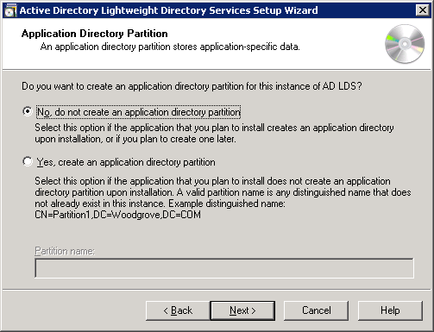
Active Directory Lightweight Directory Services Setup Wizard window
Application Directory Partition
- On File Locations:
- Browse to a location to store the data files associated with AD LDS.
C:\Program Files\Microsoft ADAM\Centurion\data
- Browse to a location to store the data recovery files associated with AD LDS.
C:\Program Files\Microsoft ADAM\Centurion\data
- Click Next.
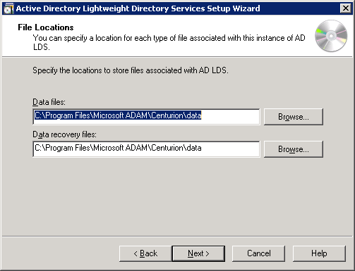
Active Directory Lightweight Directory Services Setup Wizard window
File Locations

- On Service Account Selection:
- To identify the account with which permissions are associated, select Network Service Account.
- Click Next.
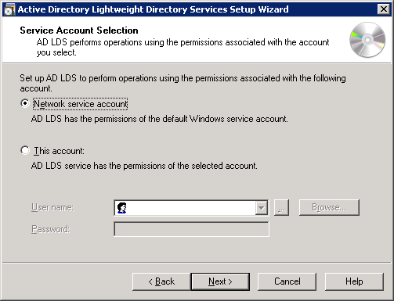
Active Directory Lightweight Directory Services Setup Wizard window
Service Account Selection
- On AD LDS Administrators:
- To assign administrative permission to AD LDS, select Currently logged on user:
<user/group of users>\Administrator.
- Click Next.
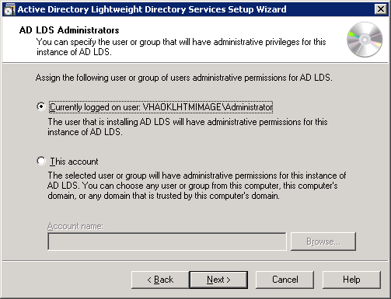
Active Directory Lightweight Directory Services Setup Wizard window
AD LDS Administrators
- On Importing LDIF Files:
- Do not select any file names.
- Click Next.
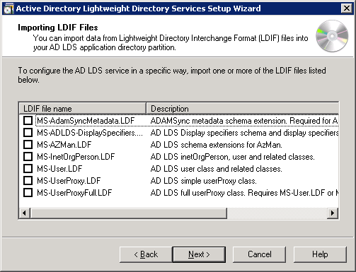
Active Directory Lightweight Directory Services Setup Wizard window
Importing LDIF Files
- Click Next on the screens that follow, until the AD LDS instance is installed.

Replace the AD/LDS Instance with Centurion Files
To replace the AD/LDS instance with the Centurion data files:
- Stop the Centurion AD/LDS service just installed.
Go into the Services section in Server Manager.
- Browse to the directory: C:\Program Files\Microsoft ADAM\Centurion\data\.
Create a new directory and name it: old.
- Move all the files from C:\Program Files\Microsoft ADAM\Centurion\data\ to
C:\Program files\Microsoft ADAM\Centurion\data\old.
- Copy the files from the %WEBHR_FILES%\ADAM directory to
C:\Program Files\Microsoft ADAM\Centurion\data\.
- Start the Centurion service.

Change the Server Name
On the Connection Settings window, change the server name of the AD/LDS Configuration.
- Use adsiedit.msc to connect to the Configuration Naming Context of the Centurion instance.
- In the Computer section, remove vhaoklhtmimage and replace with the machine name of the server that is running the Centurion AD/LDS instance.
- Click OK.
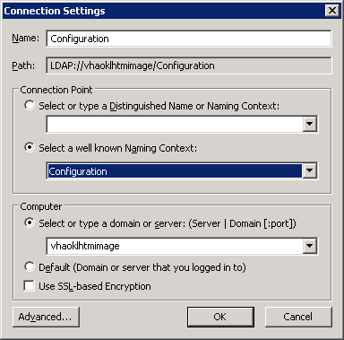
Connection Settings window
Configuration
- Navigate to the following key: CN=Servers,CN=Default-First-Site-Name,CN=Sites,CN=Configuration,CN={A5A4D5CC-DDCE-44CF-842C-12203E2FDC00}
- Right-click: CN=VHAV16HPDM1$Centurion and select rename.
- Remove VHAV16HPDM1 and replace with the machine name of the server that is hosting the Centurion instance.
- Click OK.

Install the Application Server Role
- To install the Application Server Role:
- In Server Manager, click Add Roles.
- On Select Server Roles:
- Select Server Roles.
- Select Application Server.
- Click Next.
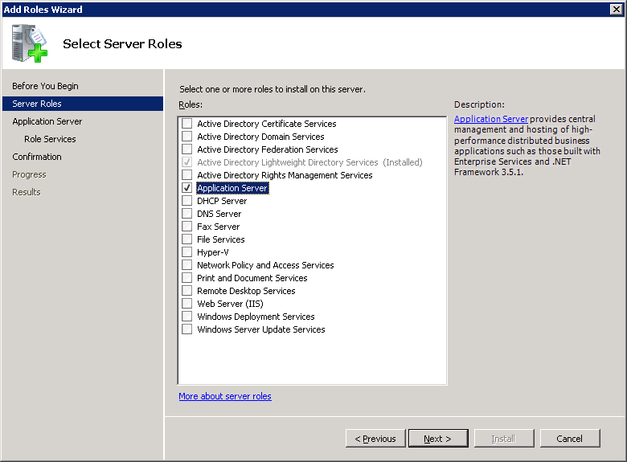
Add Roles Wizard window
Select Server Roles for Application Server
- On Select Server Services:
- Select Role Services.
- Select Web Server (IIS) Support.
- Click Next.
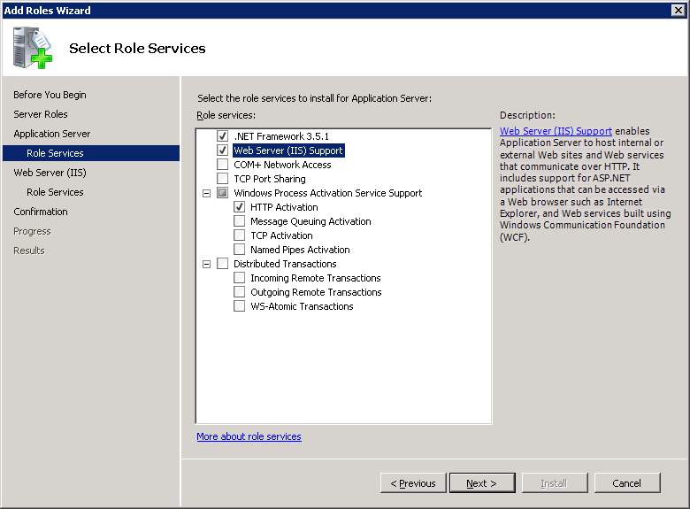
Add Roles Wizard window
Select Role Services for Web Server (IIS) Support
- Role Services defaults are selected for Web Server (IIS).
Do not remove the selected defaults.
- Click Next.
- Click Install.
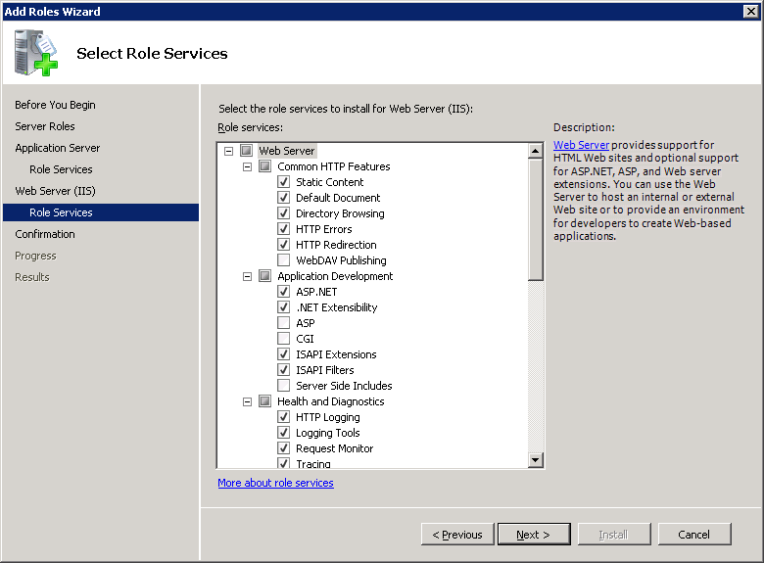
Add Roles Wizard window
Select Role Services for Web Server (IIS)

Install Microsoft .NET 4.0- Framework
To install the Microsoft .NET 4.0 Framework, if it is not installed already:
- The install files are located at: %WEBHR_FILES%\MicrosoftDotNet4
- Accept the installation defaults and the license terms.
- Click Install.
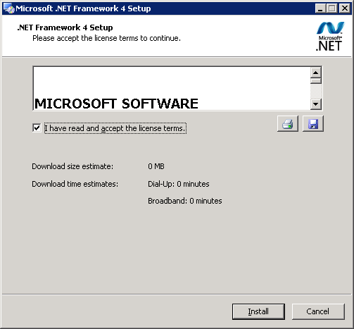
.NET Framework 4 Setup window>Accept the license terms

Install the Infragistics Net Advantage Web Client 2010
- Install the Infragistics Net Advantage Web Client 2010.
- The install files are located at: %WEBHR_FILES%\Infragistics
- Click Install ASP.NET.
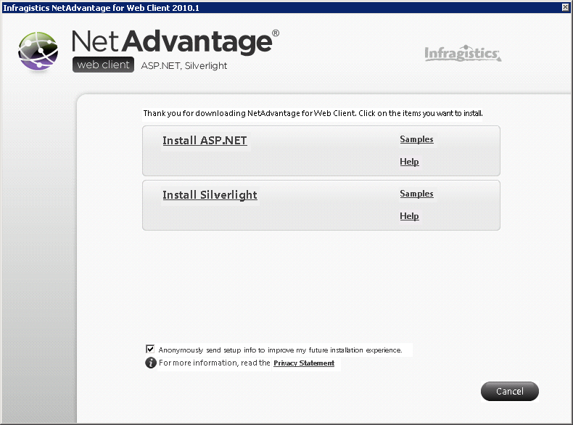
Infragistics Net Advantage Web Client>Install ASP.NET
- Click Next.
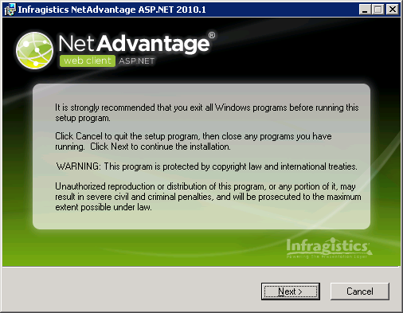
Infragistics Net Advantage Web Client>Warning page
- On Installation Notes:
- Select the radio button, I have read the installation notes.
- Click Next.
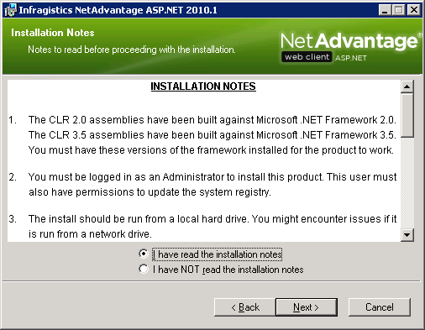
Infragistics Net Advantage Web Client>Installation Notes
- On License Agreement:
- Select the radio button, I accept the license agreement.
- Click Next.
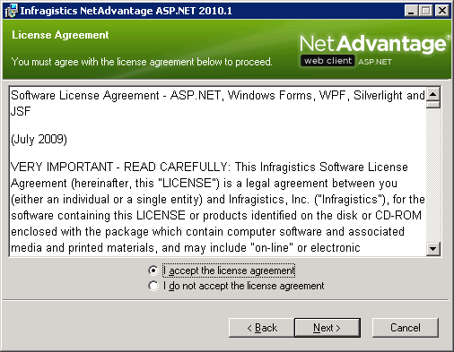
Infragistics Net Advantage Web Client>License agreement
- On User Information:
- Enter your:
- Full Name
- Organization
- Product Key
- Select the radio button, Anyone who uses this computer.
- Click Next.
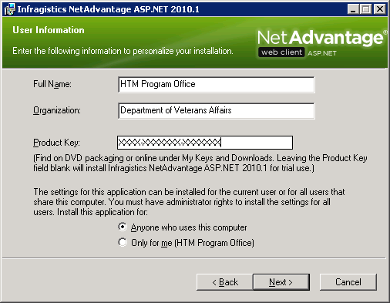
Infragistics Net Advantage Web Client>User Information page
- On Destination Folder:
- The default destination folder for Infragistics Net Advantage Web Client displays.
Do not change the default.
- Click Next.
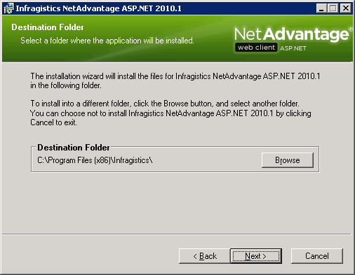
Infragistics Net Advantage Web Client>Destination Folder
- On Select Installation Type:
- Select the radio button, Complete.
- Click Next.
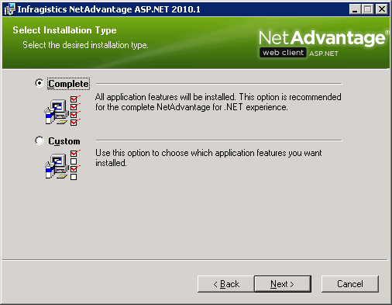
Infragistics Net Advantage Web Client>Select Installation Type
- On Ready to Install the Application, click Next.
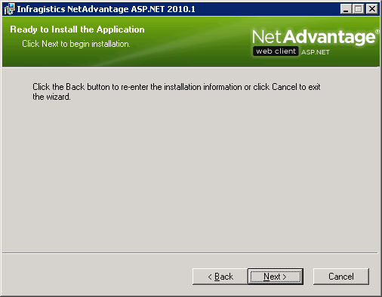
Infragistics Net Advantage Web Client>Ready to Install the Application

Install SQL Server 2008
To install SQL Server 2008:
Notes: The install files are located at: %WEBHR_FILES%\SQLServer2008.
Install SQL Server 2008 on the same machine that is running IIS.
- On SQL Server Installation Center>Planning, select Installation.
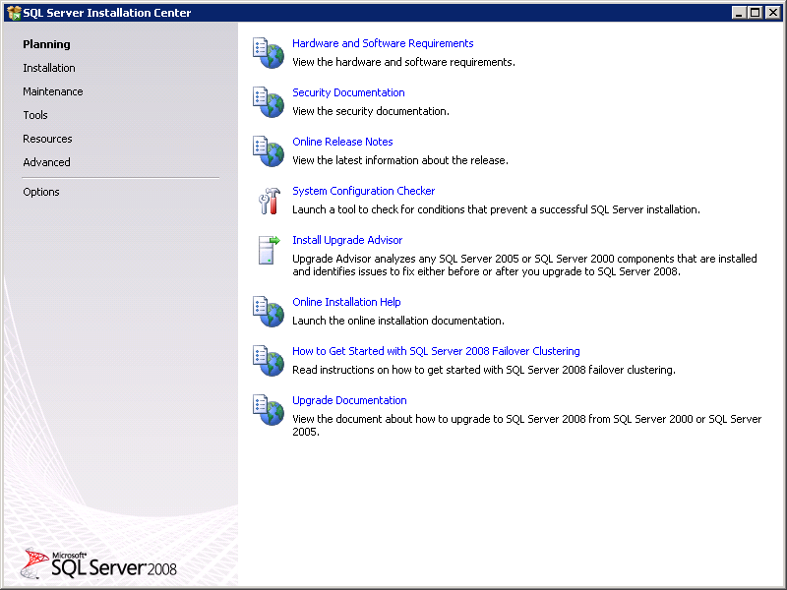
SQL Server Installation Center window>Planning
- On SQL Server Installation Center>Installation, select New SQL Server stand-alone installation or add features to an existing installation.
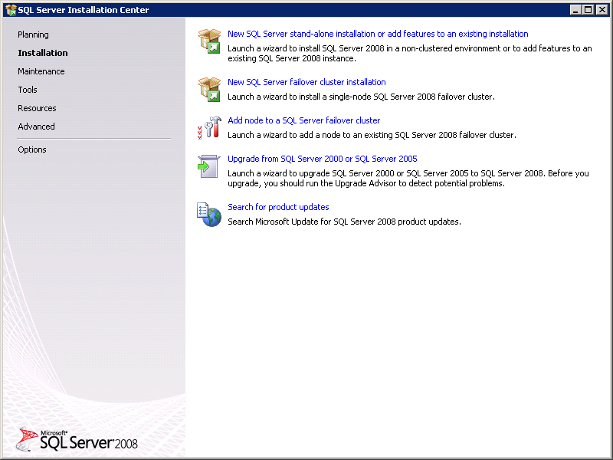
SQL Server Installation Center window>Installation
- On SQL Server 2008 Setup>Setup Support Rules, click OK.
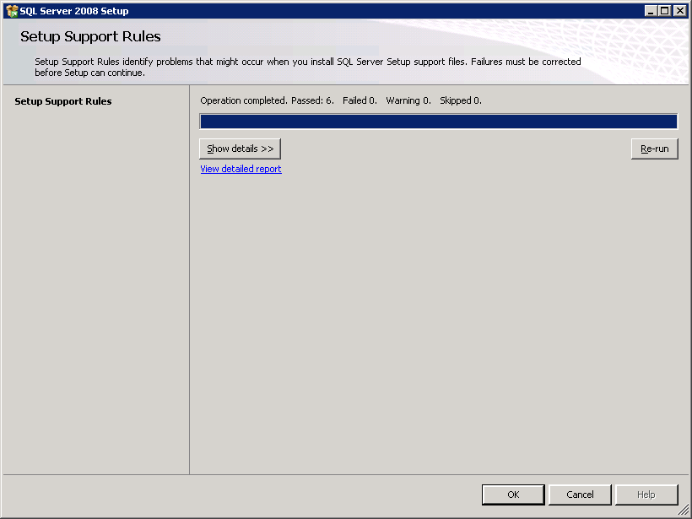
SQL Server 2008 Setup>Setup Support Rules window
- On SQL Server 2008 Setup>Product Key, enter the product key in the Enter the product key text box and click Next.
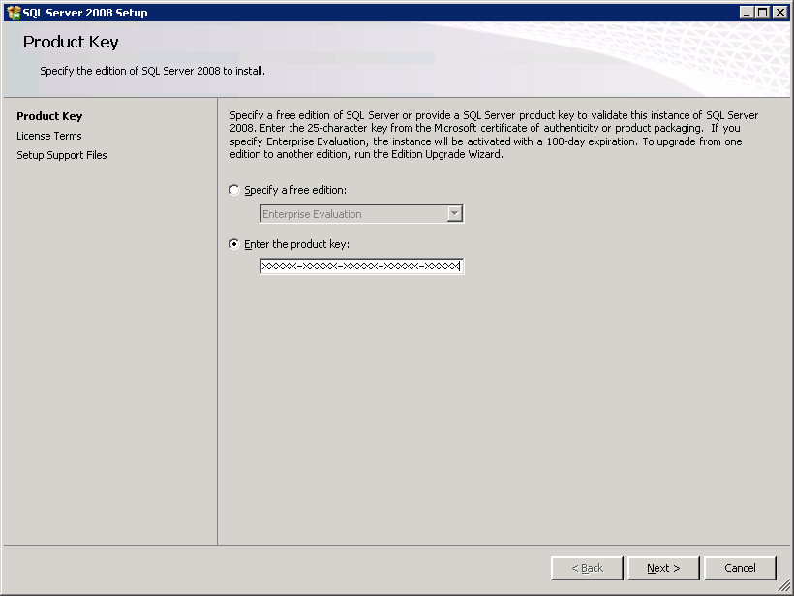
SQL Server 2008 Setup>Product Key window
- On SQL Server 2008 Setup>License Terms, select the checkbox, I accept the license terms and click Next.
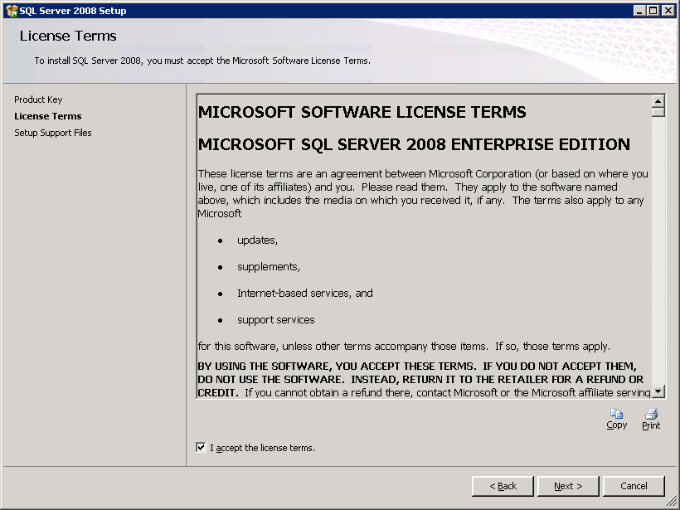
SQL Server 2008 Setup>License Terms window
- On SQL Server 2008 Setup>Setup Support Files, click Install.
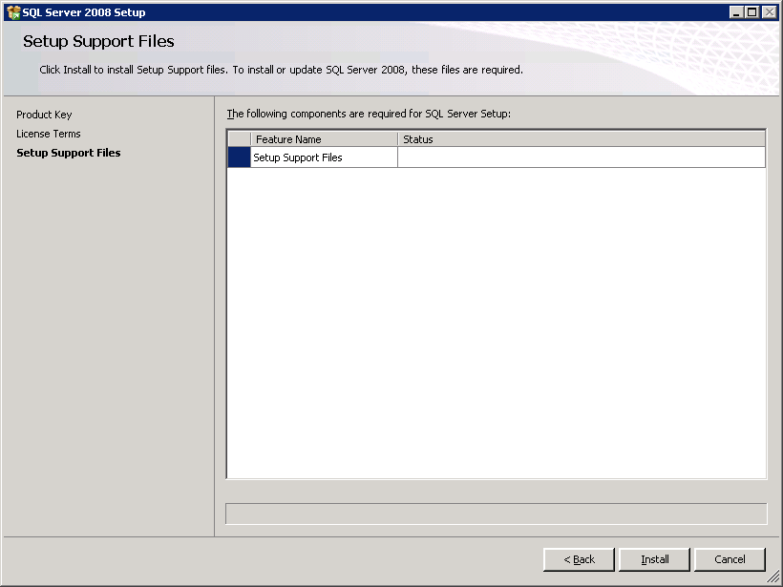
SQL Server 2008 Setup>Setup Support Files window
- On SQL Server 2008 Setup>Setup Support Rules, click Next.
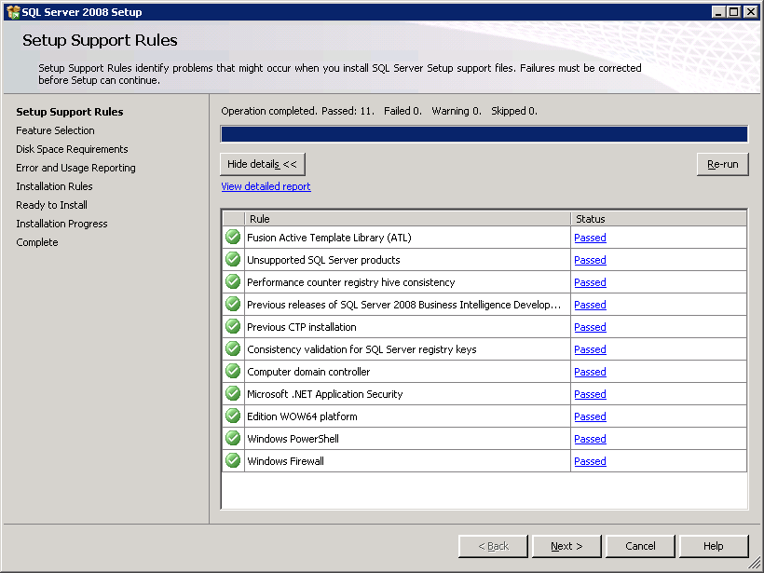
SQL Server 2008 Setup>Setup Support Rules window
- On SQL Server 2008 Setup>Feature Selection, select the following features and click Next.
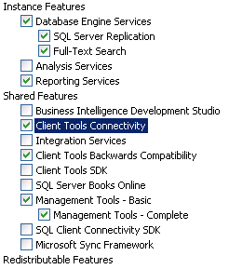
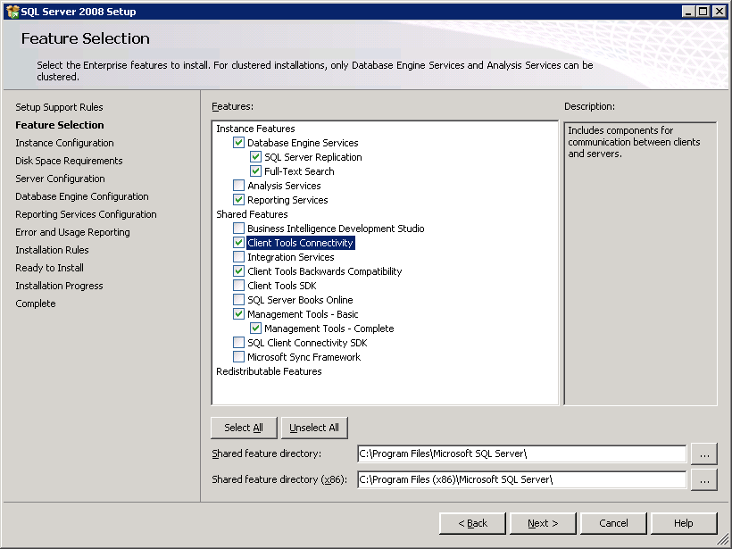
SQL Server 2008 Setup>Feature Selection window
- On SQL Server 2008 Setup>Instance Configuration, click Next.
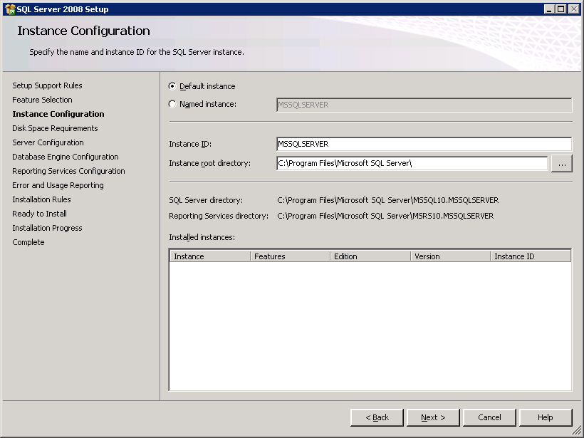
SQL Server 2008 Setup>Instance Configuration window
- On SQL Server 2008 Setup>Disk Space Requirements, click Next.
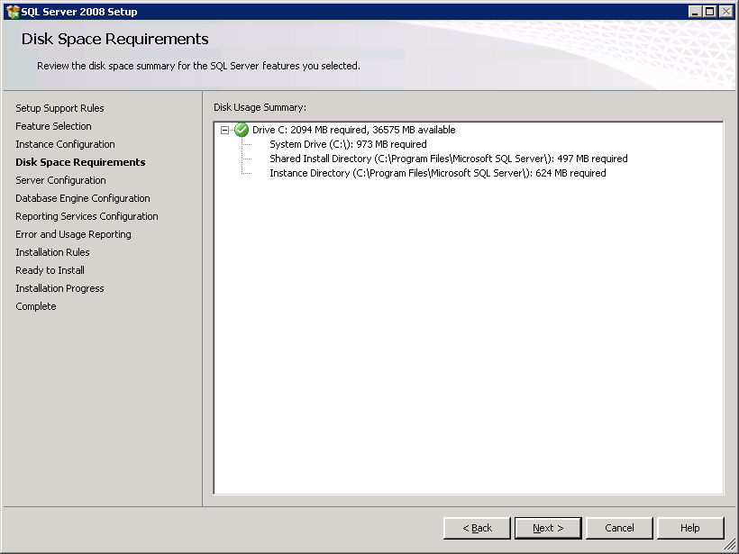
SQL Server 2008 Setup>Disk Space Requirements window

- On SQL Server 2008 Setup>Server Configuration, enter the credentials of a domain service account for: SQL Server Agent, SQL Server Database Engine, and Sql Server Reporting Services, and click Next.
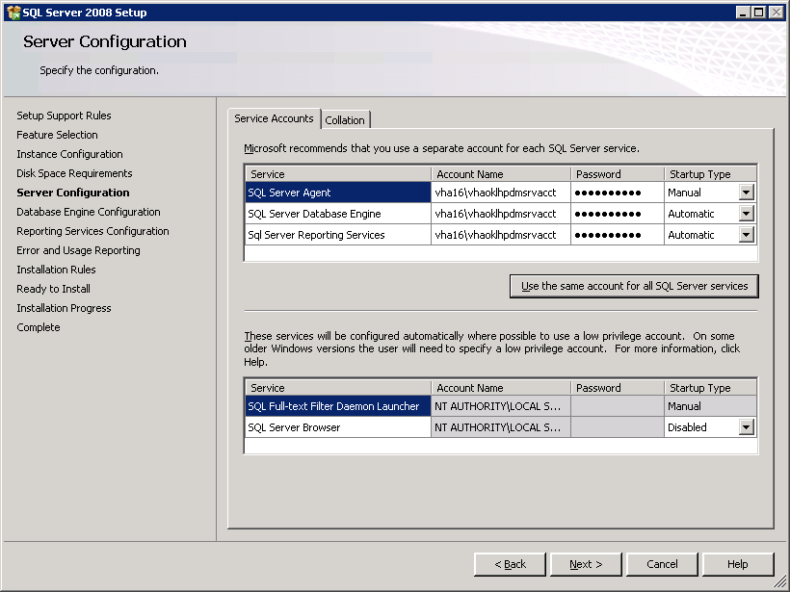
SQL Server 2008 Setup>Server Configuration window
- On SQL Server 2008 Setup>Database Engine Configuration:
- Select the radio button, Windows authentication mode.
- Enter your administrator(s) into the Specify SQL Server administrators text box and click Add.
- Click Next.
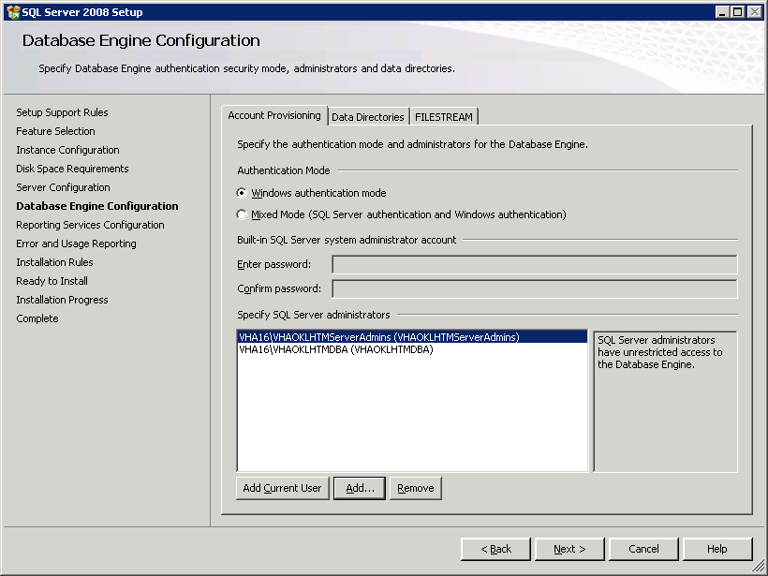
SQL Server 2008 Setup>Database Engine Configuration window
- On SQL Server 2008 Setup>Reporting Services Configuration, select the radio button, Install the native mode default configuration and click Next.
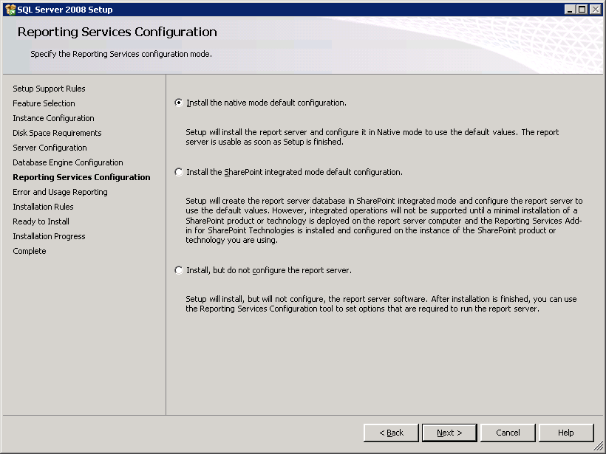
SQL Server 2008 Setup>Reporting Services Configuration window
- On SQL Server 2008 Setup>Error and Usage Reporting, click Next.
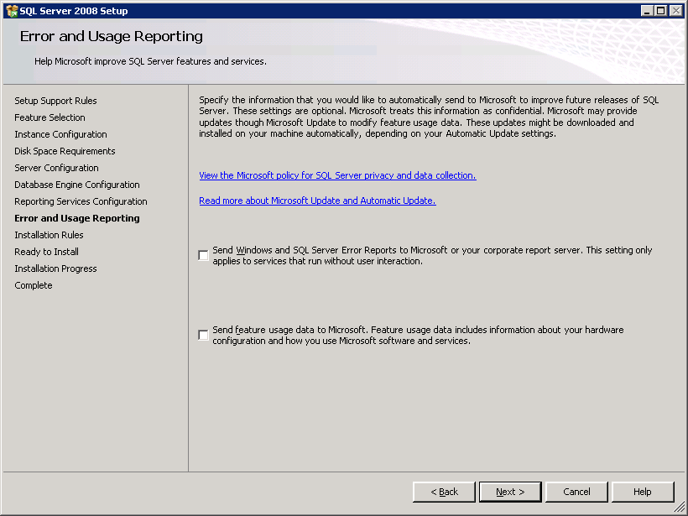
SQL Server 2008 Setup>Errors and Usage Reporting window
- On SQL Server 2008 Setup>Installation Rules, click Next.
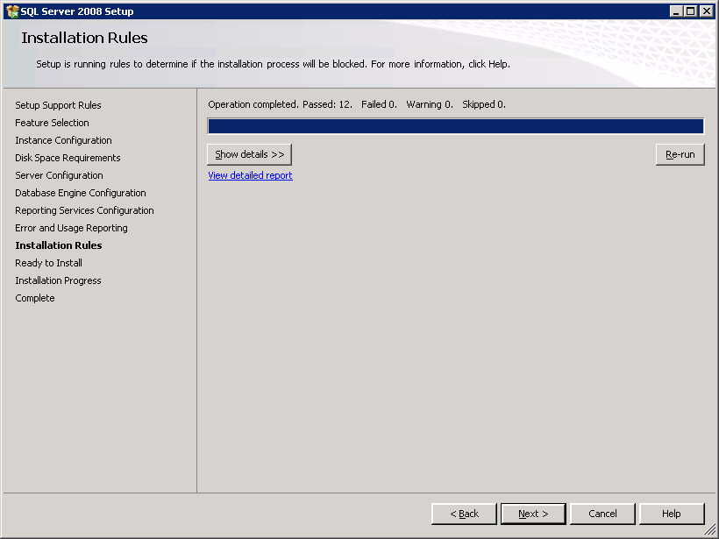
SQL Server 2008 Setup>Installation Rules window
- On SQL Server 2008 Setup>Ready to Install, click Install.
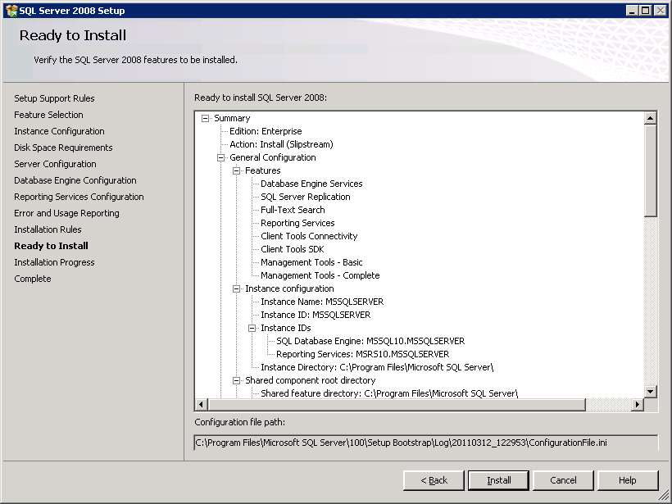
SQL Server 2008 Setup>Ready to Install window
- On SQL Server 2008 Setup>Installation Progress, click Next.
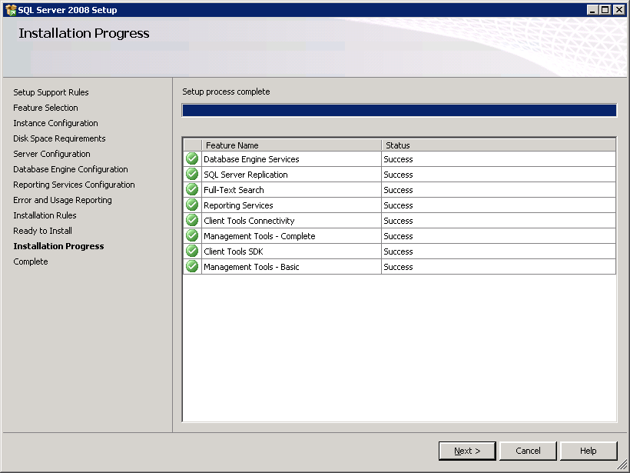
SQL Server 2008 Setup>Installation Progress window
- On SQL Server 2008 Setup>Complete, click Close.
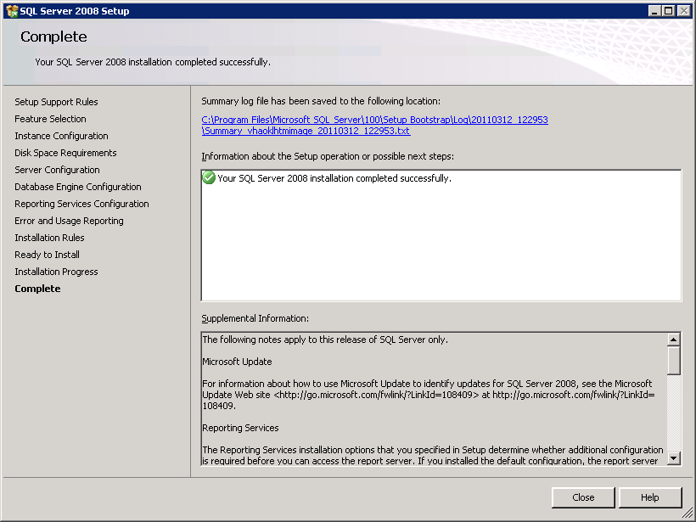
SQL Server 2008 Setup>Complete window

Create SQL Login
To create an SQL login for WebHR:
- Use SQL Management Studio to connect to your SQL Database Engine instance.
- Open a new query window and paste in the following
CREATE LOGIN [VHA16\VHAOKLVHALWDUsers] FROM WINDOWS WITH DEFAULT_DATABASE=[master], DEFAULT_LANGUAGE=[us_english]
- Click GO.

Restore Database Backup Files
To restore all the database backup files:
- Copy all the files in %WEBHR_FILES%\SQLDatabases to the default backup directory for your SQL Server installation.
The default backup directory is at registry key: HKEY_LOCAL_MACHINE\SOFTWARE\Microsoft\Microsoft SQL Server\MSSQL10.MSSQLSERVER\MSSQLServer\BackupDirectory.
- Connect to the appropriate instance of your Microsoft SQL Server Database Engine.
In Object Explorer, click the server name to expand the server tree.
- Right-click Databases and select Restore Database….In the To Database.

- On Restore Database>General:
- Destination for restore: at To database type in ARPA.
- Source for restore: select radio button, From device.
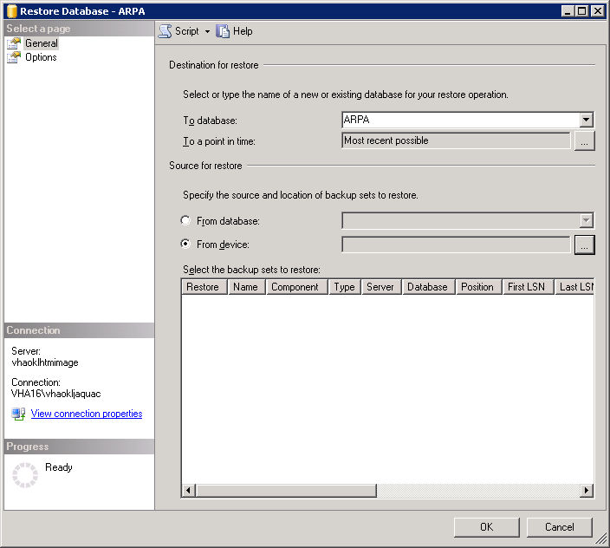
Database Restore>General
- Click directly to the right of From device.
The Specify Backup window displays.
- On Specify Backup, click Add.
- Select the ARPA database backup file.
- Click OK.
Specify Backup redisplays; click OK again.
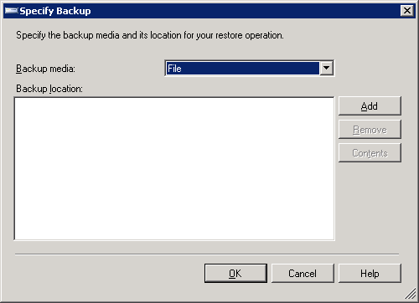
Database Restore>Specify Backup

- To start the database restore process:
- In the Select the backup sets to restore section, select the Restore check box for the item displayed in the text box.
- Click OK.
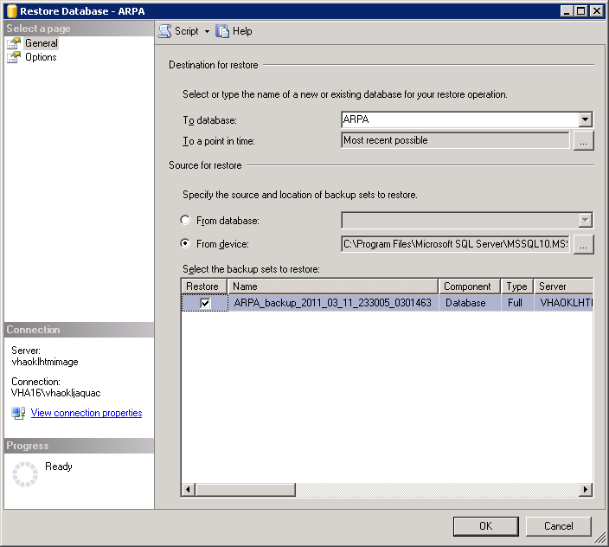
Database Restore>General
- Repeat steps 3-6 to restore each of the databases listed.
- ErrorHandling
- HR_Administration
- HR_Classification
- HR_EmployeeLabor
- HR_Forms
- HR_Global
- HR_Processing
- HR_Reports
- HR_Staffing
- HR_Workforce
- PAID
- PAID_Reports
- VA_Organizations
- vhalwd

Turn on Database Chaining
Turn on database chaining for each restored database.

- ALTER DATABASE ARPA SET DB_CHAINING ON
- ALTER DATABASE ErrorHandling SET DB_CHAINING ON
- ALTER DATABASE HR_Administration SET DB_CHAINING ON
- ALTER DATABASE HR_Classification SET DB_CHAINING ON
- ALTER DATABASE HR_EmployeeLabor SET DB_CHAINING ON
- ALTER DATABASE HR_Forms SET DB_CHAINING ON
- ALTER DATABASE HR_Global SET DB_CHAINING ON
- ALTER DATABASE HR_Processing SET DB_CHAINING ON
- ALTER DATABASE HR_Reports SET DB_CHAINING ON
- ALTER DATABASE HR_Staffing SET DB_CHAINING ON
- ALTER DATABASE HR_Workforce SET DB_CHAINING ON
- ALTER DATABASE PAID SET DB_CHAINING ON
- ALTER DATABASE PAID_Reports SET DB_CHAINING ON
- ALTER DATABASE VA_Organizations SET DB_CHAINING ON
- ALTER DATABASE VHALWD SET DB_CHAINING ON

Deploy WebHR Reports to the Report Server
Deploy the WebHR reports to the report server:
- Connect to the report server: http://<servername>/Reports.
- Create a directory called HTMCheckUP.
- Assign the Browser role to vha16\vhaoklvhalwdusers in the HTMCheckUP folder.
- Upload the WebHR report files in %WEBHR_FILES%\SQLReports to the HTMCheckUP folder.
- Create a data source with the following settings and click Apply.
- Name: PaidReports
Select Enable this data source
- Data Source Type:
Select Microsoft SQL Server
- Connection string:
Note: Remove data.dev.htm.va.gov and replace with your SQL server name.
- Data Source= data.dev.htm.va.gov;Initial
- Catalog=PAID_Reports;Network
- Library=dbmssocn
- Connect using:
Select Windows integrated security
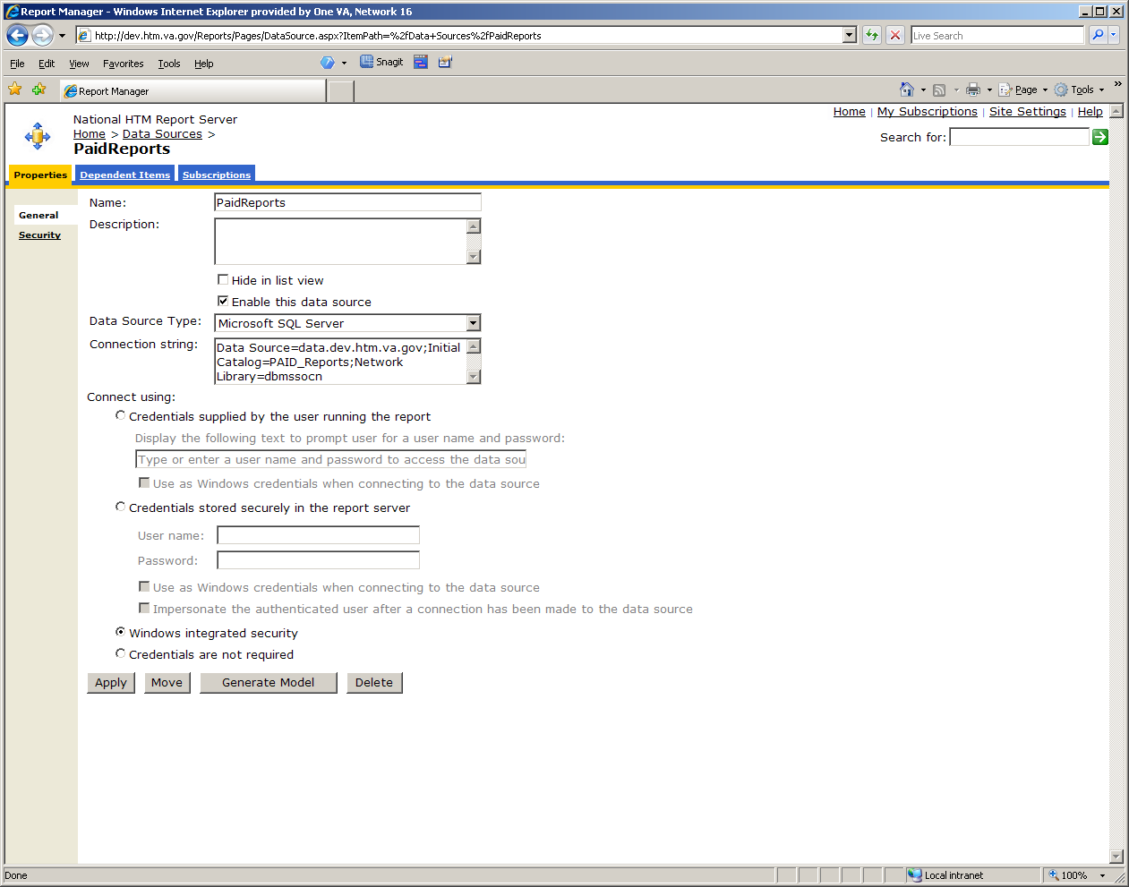
Report Manager window
PaidReports example
- Assign this data source to each new report you upload to the HTMCheckUP folder.

Deploy the WebHR Code
To deploy the WebHR code:
- Copy the %WEBHR_FILES%\Applications folder to c:\inetpub\Applications.
- Copy the %WEBHR_FILES%\Services folder to c:\inetpub\Services.

Disable IIS Anonymous Authentication
To disable IIS Anonymous Authentication:
- Open the Internet Information Services (IIS) Manager.
- Select the name of your IIS server from the tree on the left.
- Double-click the Authentication icon on the right.
- Set Anonymous Authentication to Disabled.

Change Authentication Methods
To allow the changing of authentication methods from web.config:
- Edit c:\windows\system32\inetsrv\config\applicationHost.config
- Find section: <sectionGroup name=”authentication”>
- Modify all items in this section, so overrideModeDefault is set to “Allow”:

<sectionGroup name="authentication">
<section name="anonymousAuthentication" overrideModeDefault="Allow" />
<section name="basicAuthentication"
overrideModeDefault="Allow" />
<section name="clientCertificateMappingAuthentication" overrideModeDefault="Allow" />
<section name="digestAuthentication" overrideModeDefault="Allow" />
<section name="iisClientCertificateMappingAuthentication" overrideModeDefault="Allow" />
<section name="windowsAuthentication" overrideModeDefault="Allow" />
</sectionGroup>

Modify Default Application Pool
To modify the default application pool:
- In the application pools section, change the .Net Framework version of the DefaultAppPool to v4.0.
- In IIS Manager, drill down to the Default Web Site section.

Add Applications to Pool
Add applications to the default application pool.
For WebHR.Net
- Right-click Default Web Site and select Add Application.
- For Site name: Default Web Site, enter the following values.
- Alias: WebHR.Net
- Physical path: C:|\inetpub\Application\WebHR.Net
- Click OK.
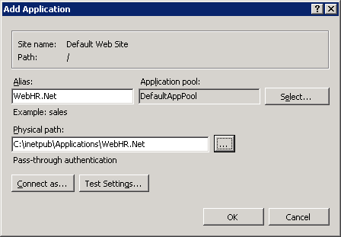
Add Application window
WebHR.Net
For ARPA.Net
- Right-click Default Web Site and select Add Application.
- For Site name: Default Web Site, enter the following values.
- Alias: ARPA.Net
- Physical path: C:|\inetpub\Applications\ARPA.NET
- Click OK.
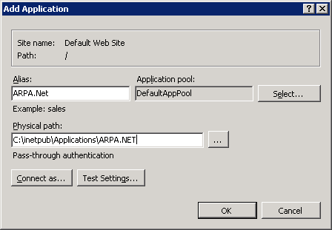
Add Application window
ARPA.Net
For Common
- Right-click Default Web Site and select Add Application.
- For Site name: Default Web Site, enter the following values.
- Alias: Common
- Physical path: C:|\inetpub\Services\Common
- Click OK.
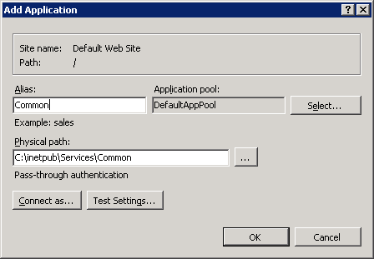
Add Application window
Common
For HR_Services
- Right-click Default Web Site and select Add Application.
- For Site name: Default Web Site, enter the following values.
- Alias: HR_Services
- Physical path: C:|\inetpub\Services\HR_Services
- Click OK.
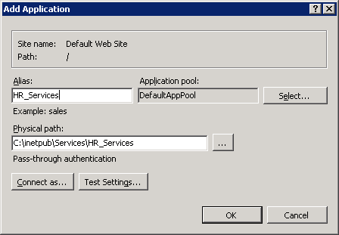
Add Application window
HR_Services
For HTM_DMS
- Right-click Default Web Site and select Add Application.
- For Site name: Default Web Site, enter the following values.
- Alias: HTM_DMS
- Physical path: C:|\inetpub\Services\HTM_DMS
- Click OK.
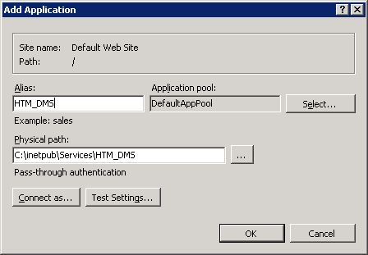
Add Application window
HTN_DMS
For PaidServices
- Right-click Default Web Site and select Add Application.
- For Site name: Default Web Site, enter the following values.
- Alias: PaidServices
- Physical path: C:|\inetpub\Services\ PAIDServices
- Click OK.
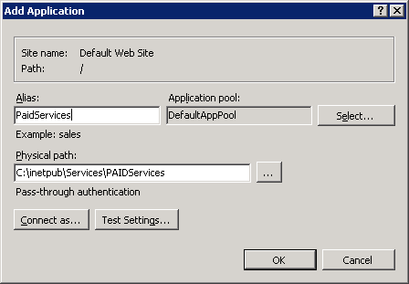
Add Application window
PaidServices
For VAAD
- Right-click Default Web Site and select Add Application.
- For Site name: Default Web Site, enter the following values.
- Alias: VAAD
- Physical path: C:|\inetpub\Services\VAAD
- Click OK.
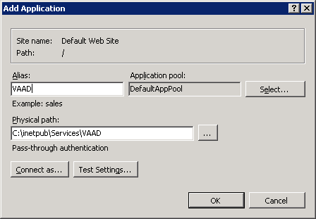
Add Application window
VAAD
For VulcanServices
- Right-click Default Web Site and select Add Application.
- For Site name: Default Web Site, enter the following values.
- Alias: VulcanServices
- Physical path: C:|\inetpub\Services\VulcanServices
- Click OK.
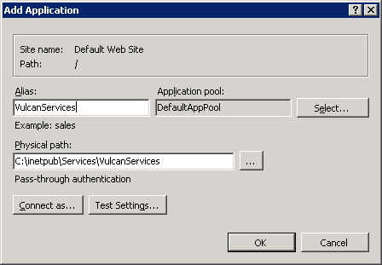
Add Application window
VulcanServices

Change uploadReadAheadSize
For SSL, change uploadReadAheadSize.
- cd c:\windows\system32\inetsrv
- appcmd.exe set config-section:system.webServer/serverRuntime /uploadReadAheadSize:"1048576" /commit:apphost

Change Machine Configuration
If running the server in FIPS mode, change the machine configuration.
- Edit:
C:\Windows\Microsoft.NET\Framework64\v4.0.30319\Config\machine.config
- Inside the <system.web> section, add:

<machineKey validationKey="AutoGenerate,IsolateApps" decryptionKey="AutoGenerate,IsolateApps" validation="3DES" decryption="3DES"/>

Test Installation
To test your installation, use the following links to access WebHR:
- http[s]://<servername>/WebHR.Net
- http[s]://<servername>/ARPA.Net

Post-installation Considerations

Updating WebHR
A WebHR update can contain database changes, application build changes, and SQL Server report changes. These changes are deployed and tested on a QA server prior to being placed into Production. A tester is assigned to testing the new version.

Once the new version of WebHR passes the testing processing, the WebHR developer provides the Production deployment team with the database changes, application build changes, and report changes for the new version. The Production deployment team schedules downtime for the changes to be applied to the Production system.

Example

- The testers notify the Production deployment team that the next version of WebHR has passed QA testing.
- The WebHR developer informs the Production deployment team:
- The update affects WebHR.Net, ARPA.Net, and HR_Services
- About the database changes included in this update
- About a report file (.rdl) that requires updating on the report server.
- The WebHR web sites are taken off line.
- The following directories are backed up on the server:
- c:\inetpub\Applications\WebHR.Net,
- c:\inetpub\Applications\ARPA.Net
- c:\inetpub\Services\HR_Services
- The contents of the three directories are deleted.
- The new application build is copied into the three directories.
- While this is occurring:
- The DBA applies an SQL script to make the necessary database changes
- The report file is deployed to the production report server.
- The web site is brought back on line.

Back-out/Uninstall Procedures
If any problems are encountered during or after an update/installation, the Production deployment team rolls back WebHR to the previous version, using backups that were generated before an update/installation.

Troubleshooting Common Installation Issues
WebHR logs error messages to an ErrorHandling Database in the SQL Database Engine instance.
- Inside the ErrorHandling database, there is a table called ELMAH_Error.
- The ELMAH_Error table logs the error message, user that received the error message, and the date/time of the error message.

Problem | Cause | Solution
Error: Page cannot be displayed | When running a server in FIPS mode, https: uses TLS 1.0 | Enable TLS 1.0 in Internet Explorer  - Tools->Internet Options-> Advanced tab  - Select TLS 1.0
Username/Password dialog box when accessing WebHR | Integrated security credentials are not passed to WebHR | Add *.va.gov to the Local Intranet Sites in Internet Explorer
Username/Password dialog box when accessing WebHR | User does not have permission to the WebHR page | Add the user account to the correct WebHR Role
Login fails for user NT AUTHORITY\ANONYMOUS LOGON | WebHR is trying to access an SQL database that does not reside on the same server as the IIS server | Modify the WebHR build, so it connects to the correct SQL database engine server
Login fails for user NT AUTHORITY\ANONYMOUS LOGON | The user account is not in the vha16\vhoklvhalwdusers group. Therefore, the group does not have permission to access the database. | In Active Directory, add the user account to the vha16\vhaoklvhalwdusers group
Error: Permission denied  when running stored procedures that access tables or stored procedures contained in another database | Database chaining is not turned on for the databases | ALTER DATABASE <DatabaseName> SET DB_CHAINING ON
 | The databases you are trying to access have different owners | - In SQL Management Studio, right-click the Database and select Properties.  - Go to the Files Section and set the owner of the database to the same owner as the other databases.

